SMALL TALK
CARD A

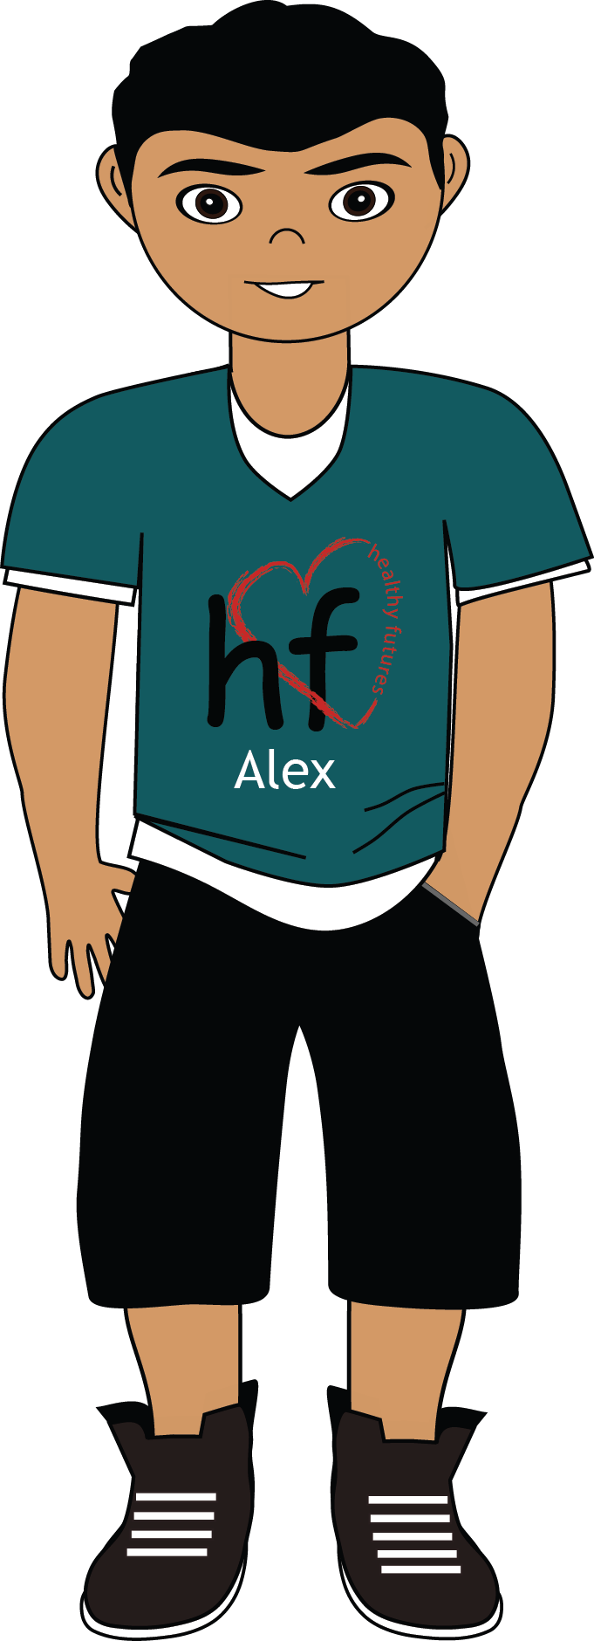
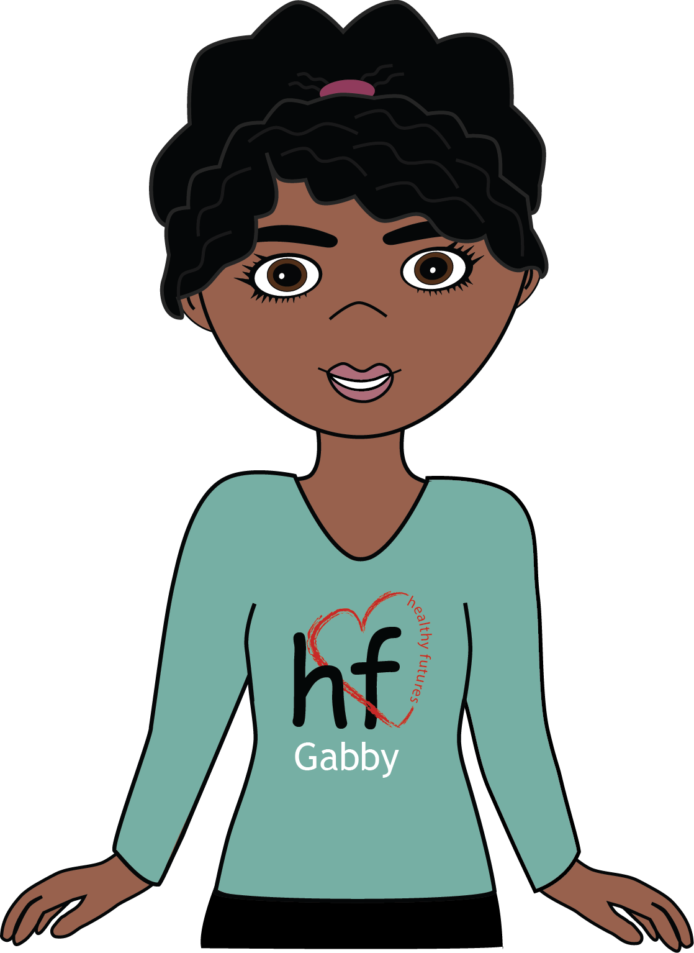
- Discuss the weather outside. (Do they
like it, do they hate it?)
- Finish by asking each person about their interests. (Music, T.V., movies, sports, foods, etc.)
- Greet the other members of your group by saying “Hello my name is __________. And you are?”

- Shake hands and say, “It’s nice to meet you.”

- Ask them how they are today.

Before you begin your
discussion, inform everyone in
your group that this is a pretend
conversation that people would
have if they were just meeting
for the first time.

When instructed, use
this card to have a discussion
with your other classmates. You are responsible for leading this conversation. Follow the
instructions below.

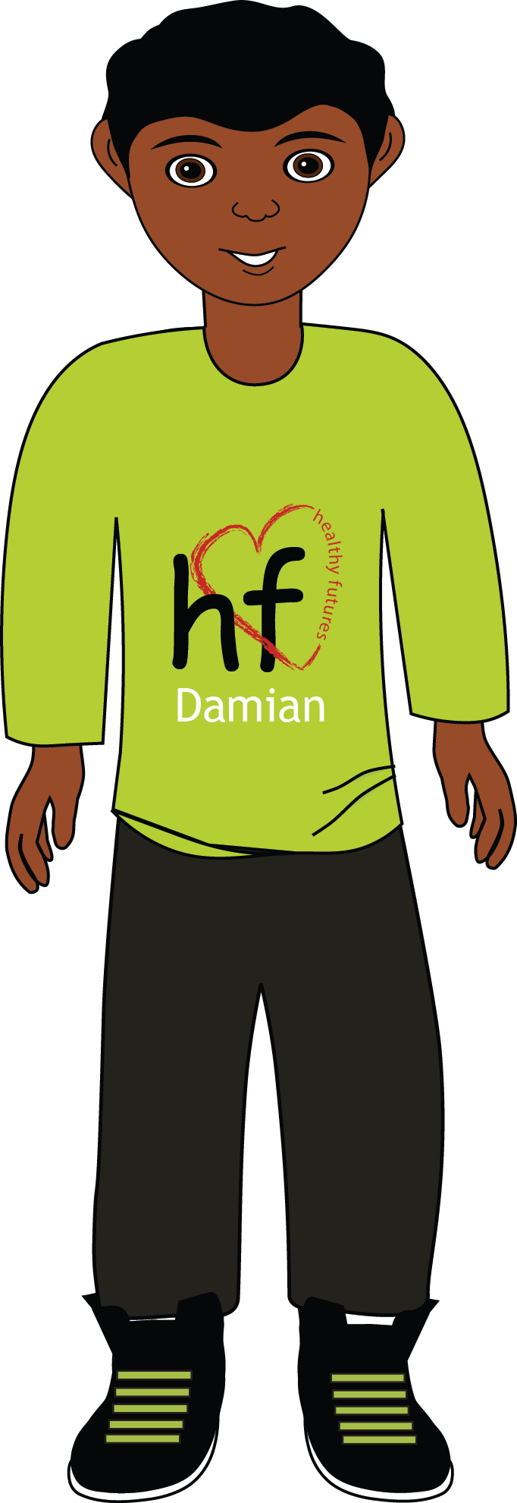
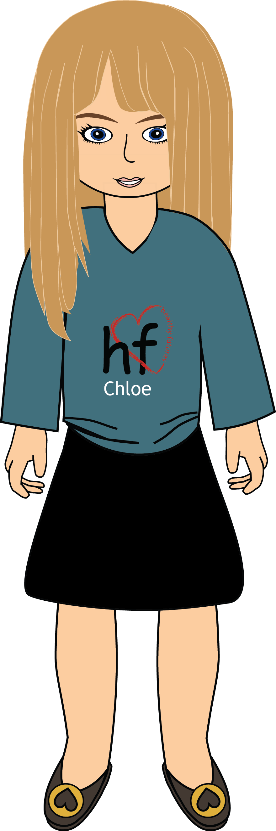
- Greet the other members of your group by saying “Hey __________. What’s up?!”

- Talk about the interests they shared during the first round.

- Pretend and discuss other things you might have in common. (Singers, sports teams, T.V. shows, movies, food, etc.)
- Talk about a class that you’re
both in. Discuss the class, the
teacher, the material, homework,
etc.
- Close the conversation by pretending to remember a common experience you all shared. (A fun field trip, a game you’ve played together, or a person you all think is cool)

Before you begin your
discussion, inform everyone in
your group that this is a pretend
conversation that people would
have if they were friends but not best friends.

When instructed, use
this card to have a discussion
with your other classmates. You
are responsible for leading this conversation. Follow the
instructions below.
SMALL TALK
CARD B

SMALL TALK
CARD C

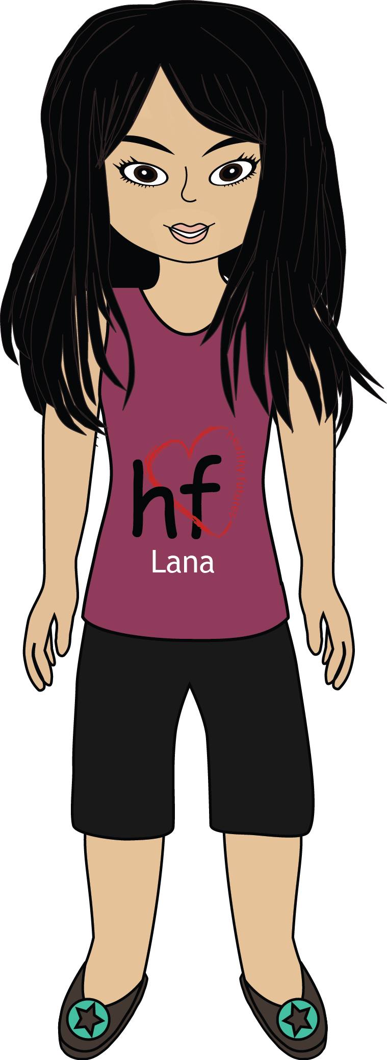
- Ask everyone how their day is going. When you respond say something like “I’m happy because ________”.

- Catch up on a favorite T.V. show that you all enjoy, the newest song, or everyone’s favorite sports team.
- Say “I’m nervous about tomorrow
because ___________”.

- Finish by talking about something
you plan to do together this weekend. (Play video games, go to the movies, hang out at someone’s birthday party, etc.)

Before you begin your
discussion, inform everyone
in your group that this is a
pretend conversation that
people would have if they
were all close friends.

When instructed, use
this card to have a discussion
with your other classmates. You
are responsible for leading this conversation. Follow the
instructions below.

